Bristol Chapter – Massachusetts Society of Genealogists │ Boston Public Library Tour
Saturday, May 16, 2026
Join us for a guided tour of one of Boston’s greatest cultural landmarks — no business meeting this month!
🕚 Schedule
9:00 AM | Library opens
10:00 AM | Guided tour begins — meet at the Main Entrance
After tour | Optional individual research time available

📍 Location  Boston Public Library  700 Boylston Street, Boston  Accessible entrance on Boylston Street | 🏛 Tour Includes  - Building highlights  - Genealogy room  - Time for individual research

🚆 Getting There and Returning
Train  - $10 Saturday weekend ticket  - Providence line departs 8:15 AM, arrives 9:25 AM  - Stops: Pawtucket, Attleboro, Mansfield & more  - Franklin Line: transfer to Fairmount Line  - Walk 7–10 min from Back Bay Station  - Note: Fall River Depot arrives too late  - Return trips from Back Bay start as early as 12:20 pm – Check the schedule for returns and arrivals | Subway  - Green Line to Copley Station  - Station is directly across from the BPL entrance | Driving  - Carpooling encouraged  - Parking ~$25/day in nearby garages  - Approx. 1 hour drive (varies by location & traffic)

📚 Research Tips
- Prepare in advance for closed-stack materials
- Limit: 1 closed-stack item per person
- A physical BPL library card is required for closed-stack requests
- BPL holds many MA newspapers not yet digitized
- Identify microfilm titles ahead of time on the BPL website
- You may stay after the tour for your own research

☕ Food & Dining

Two cafés inside the library | Tearoom — lunch reservations available | Train riders: consider eating breakfast en route

🗺 Walking from Back Bay Station
~7–10 minute walk (0.2 miles) along Dartmouth Street to the BPL entrance on Boylston Street
Boston Public Library │ 700 Boylston Street, Boston, MA

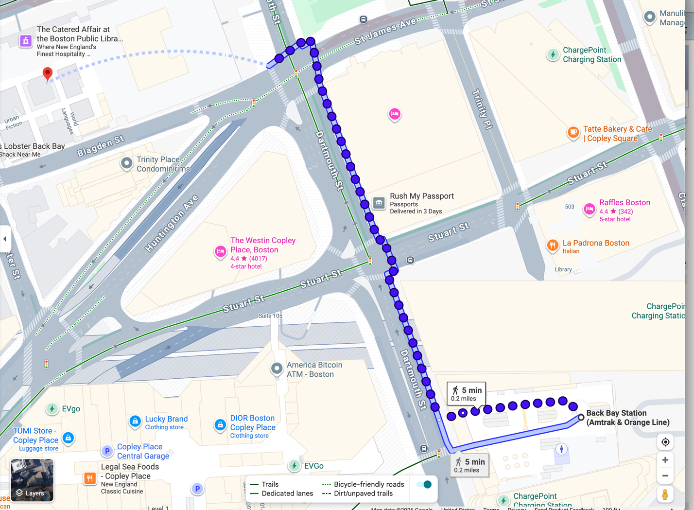
Google Maps

